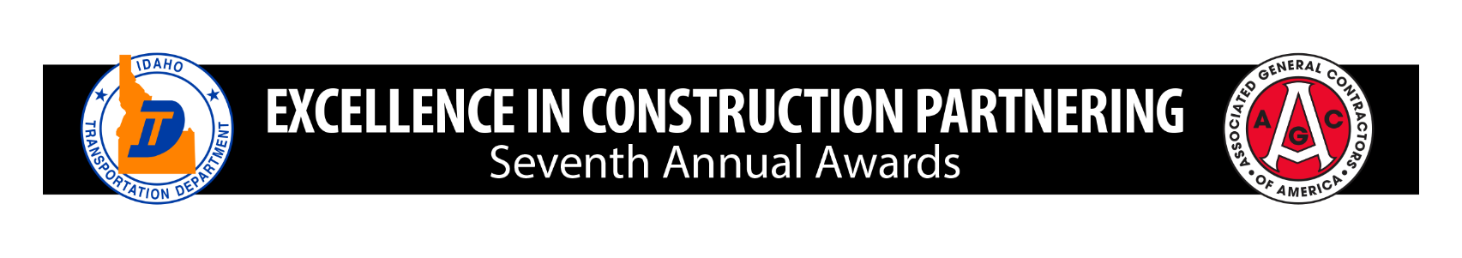

ITD/AGC Annual Excellence in Construction Partnering Awards

- 2026 Nomination Form ‐

***Project must be completed within the last 12 months or scheduled to be completed by end of calendar year***

Contract Number/Route/Milepost: | Construction Engineer:
Project Name: | Date Project Started:
Contractor Name: | Date Project Completed (or scheduled):
Email: | Phone #:

Category of Award (select one):

State Highway Project

Local Road Project

Application:

Please provide an overview of the project and examples of how partnering helped get the job done.

Brief Project Overview (500 characters or less):

Partnering Success (2,000 characters or less):

Must include the following:

Specific details on how partnering contributed to the successful completion of the project

What specific challenges you faced and how you worked together to overcome them

ITD Applicant or Local Agency Contact Name

ITD or Local Agency Applicant Signature

Contractor Applicant Signature

A valid application package should include a completed and submitted nomination form, 3‐5 photos emailed to ITDCommunication@itd.idaho.gov with project name in the subject line, all received by 12 p.m. MST on November 6, 2026.

Please contact ITDCommunication@itd.idaho.gov with application questions

